AGASD Sapphire Community Web Portal Instructions

Please visit our website www.agasd.org, under the “Find It Fast” section you will see the link to the Community Portal.

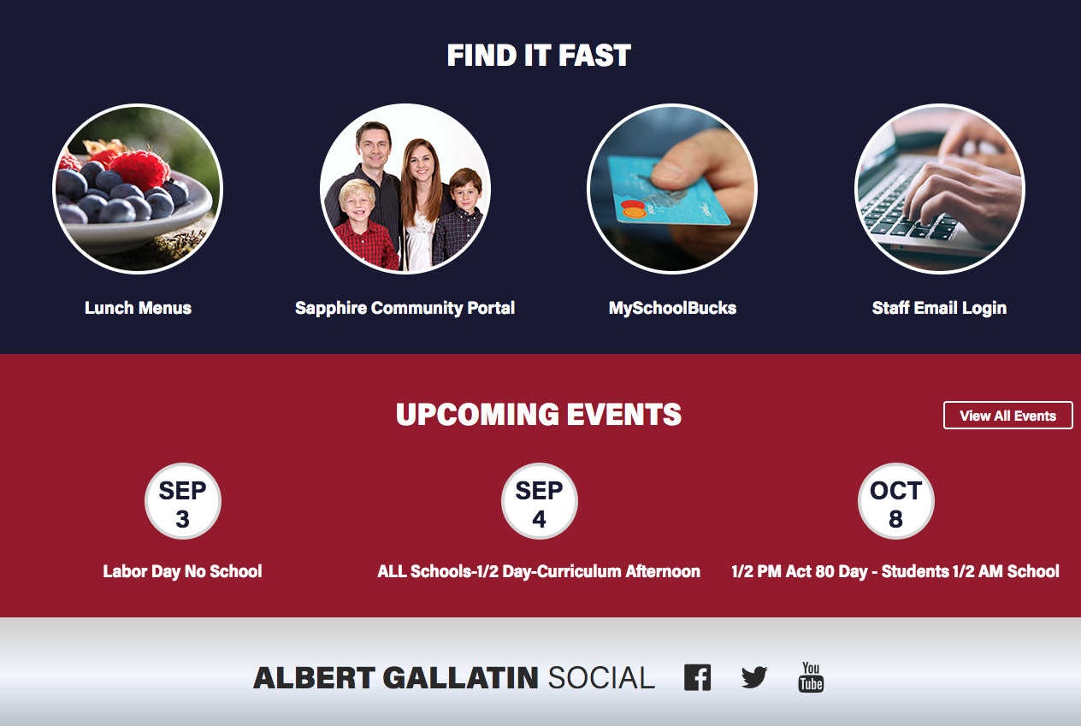

Once on the Welcome page, please click on “Create a Web Portal Account”.

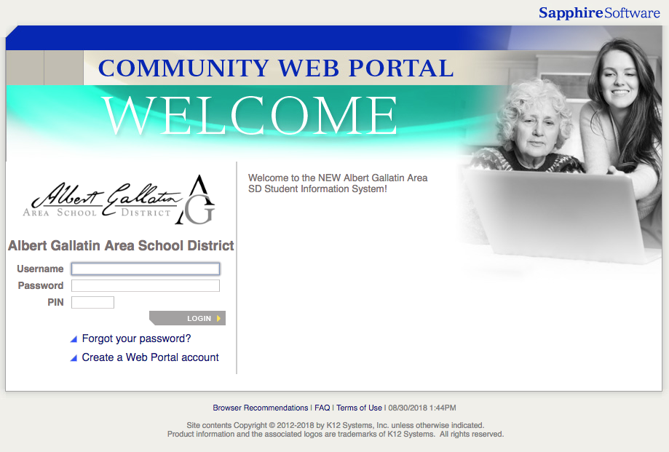

You will need the KEYWORD (colonials1) in order to proceed to the account page.

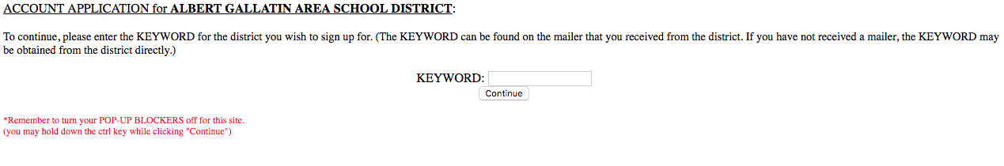

Please review the agreement and choose “I agree” to continue.

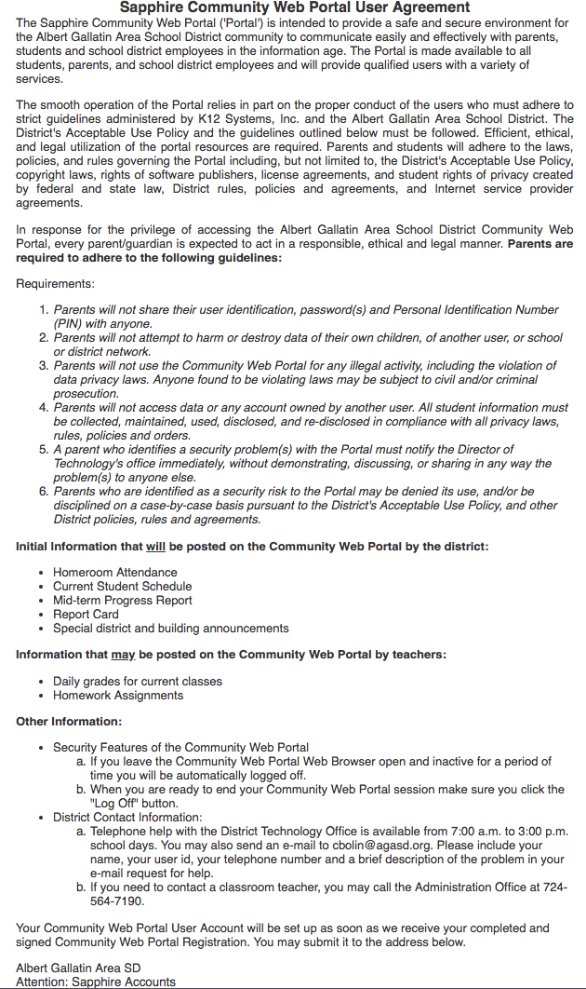

Please fill out the information that is required to obtain your account. Once the form is filled out, please submit and print a copy and mail it to the address listed. Once the school administrator approves your account, you will be emailed your PIN.

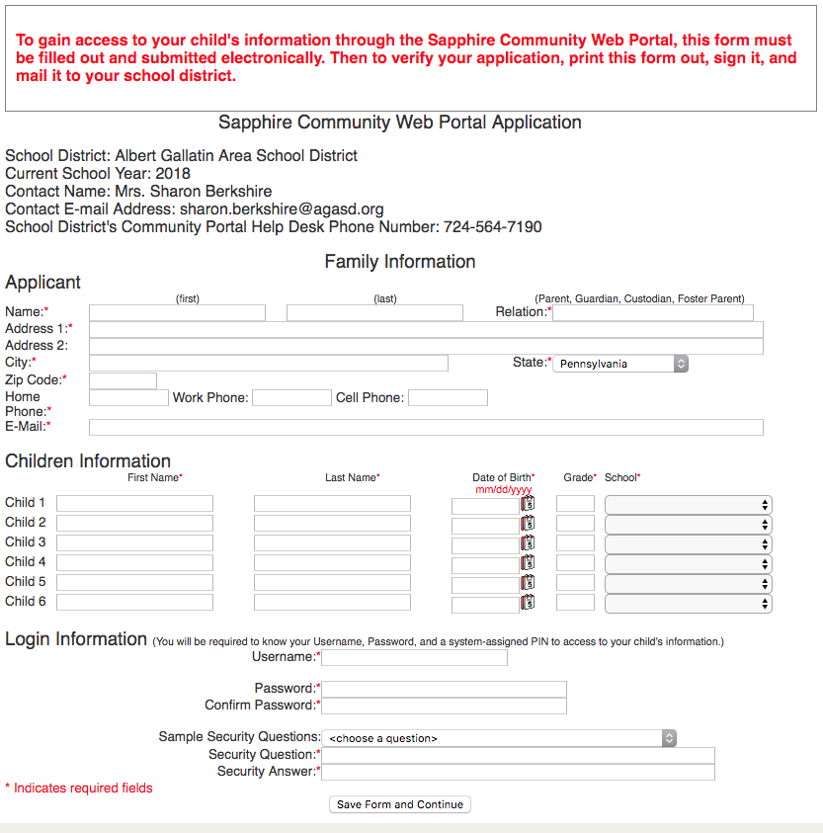

Thank you!

